**Lou Geh Library System**

The library contains one or several copies of the same book. Every copy of a book has a copy number and is located at a specific location in a shelf. A copy is identified by the copy number and the ISBN number of the book. Every book has a unique ISBN, a publication year, a title, an author, and a number of pages. Books are published by publishers. A publisher has a name as well as a location. Within the library system, books are assigned to one or several categories. A category can be a subcategory of exactly one other category. A category has a name and no further properties. Each reader needs to provide his/her family name, his/her first name, his/her city, and his/her date of birth to register at the library. Each reader gets a unique reader number. Readers borrow copies of books. Upon borrowing the return date is stored.

**Entity-Relationship Diagram**

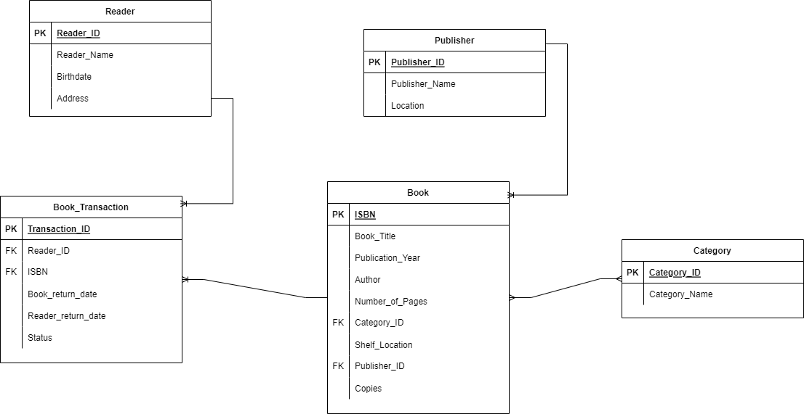

**Normalization**

The ERD above is in third normal form (3NF), which means there are no transitive functional dependencies or partial functional dependencies in the ERD. This means that all of the non-key attributes are fully functionally dependent on the primary key, and that there are no redundant relationships between the entities.

* The Publisher entity has a primary key of Publisher_ID. The Publisher_Name and Location attributes are fully functionally dependent on the Publisher_ID, meaning that they cannot exist without a Publisher_ID.
* The Book entity has a primary key of ISBN. The Book_Title, Pubication_Year, Author, Number_of_Pages, Copies, Shelf_Location, and Category_ID attributes are fully functionally dependent on the ISBN.
* The Category entity has a primary key of Category_ID. The Category_Name attribute is fully functionally dependent on the Category_ID.
* The Reader entity has a primary key of ReaderID. The Reader_Name, Birthdate, and Address attributes are fully functionally dependent on the Reader_ID.
* The Book_Transaction entity has a primary key of Transaction_ID. The Reader_ID, ISBN, Book_return_date, Reader_return_date and Status attributes are fully functionally dependent on the Transaction_ID.

The cardinality of the ERD is as follows:

* Book - Book Transaction: One-to-many. This means that a single book entry can have many book transaction entries.
* Publisher - Book: One-to-many. This means that a single publisher can have many book entries.
* Category - Book: Many-to-many. This means that a single book entry can belong to many categories, and a single category can have many book entries.
* Reader - Book Transaction: One-to-many. This means that a single reader can have many book transaction entries, and a single book transaction entry can belong to one readers.

**Entities**

* Publisher: Stores information about publishers, such as their name and address.
* Book: Stores information about books, such as their title, author, and ISBN.
* Category: Stores information about book categories, such as fiction, non-fiction, and children's books.
* Reader: Stores information about readers, such as their name, birthdate, and address.

**Attributes**

* Publisher:
  + Publisher_ID
  + Publisher_Name
  + Location
* Book:
  + ISBN
  + Book_Title
  + Publication_Year
  + Author
  + Number_of_Pages
  + Category_ID
  + Shelf_Location
  + Copies
* Category:
  + Category_ID
  + Category_Name
* Reader:
  + Reader_ID
  + Reader_Name
  + Birthdate
  + Address
* Book Transaction:
  + Transaction_ID
  + Reader_ID
  + Copy_Number
  + Book_return_date
  + Reader_return_date
  + Status

**Keys**

A primary key is a unique identifier for each row in a table. A foreign key is a column that references the primary key of another table. This is how relationships between tables are created. Below are the keys found in the ERD above:

* Publisher: Publisher_ID
* Book Info: ISBN
* Category: Category_ID
* Reader: Reader_ID
* Book Transaction: Transaction_ID